Salesforce granting access to content folder
- Go to Files tab and drop down on the respective folder
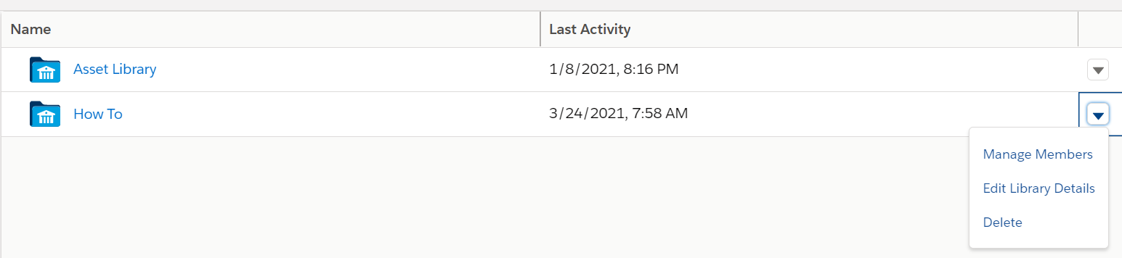
- Choose the access level and the public group to share the folder with
